Name : Saurabh Jadhav

Title : Create S3 bucket.

Assignment no. : 13

1. Navigate to Amazon S3 instance and click on create bucket.

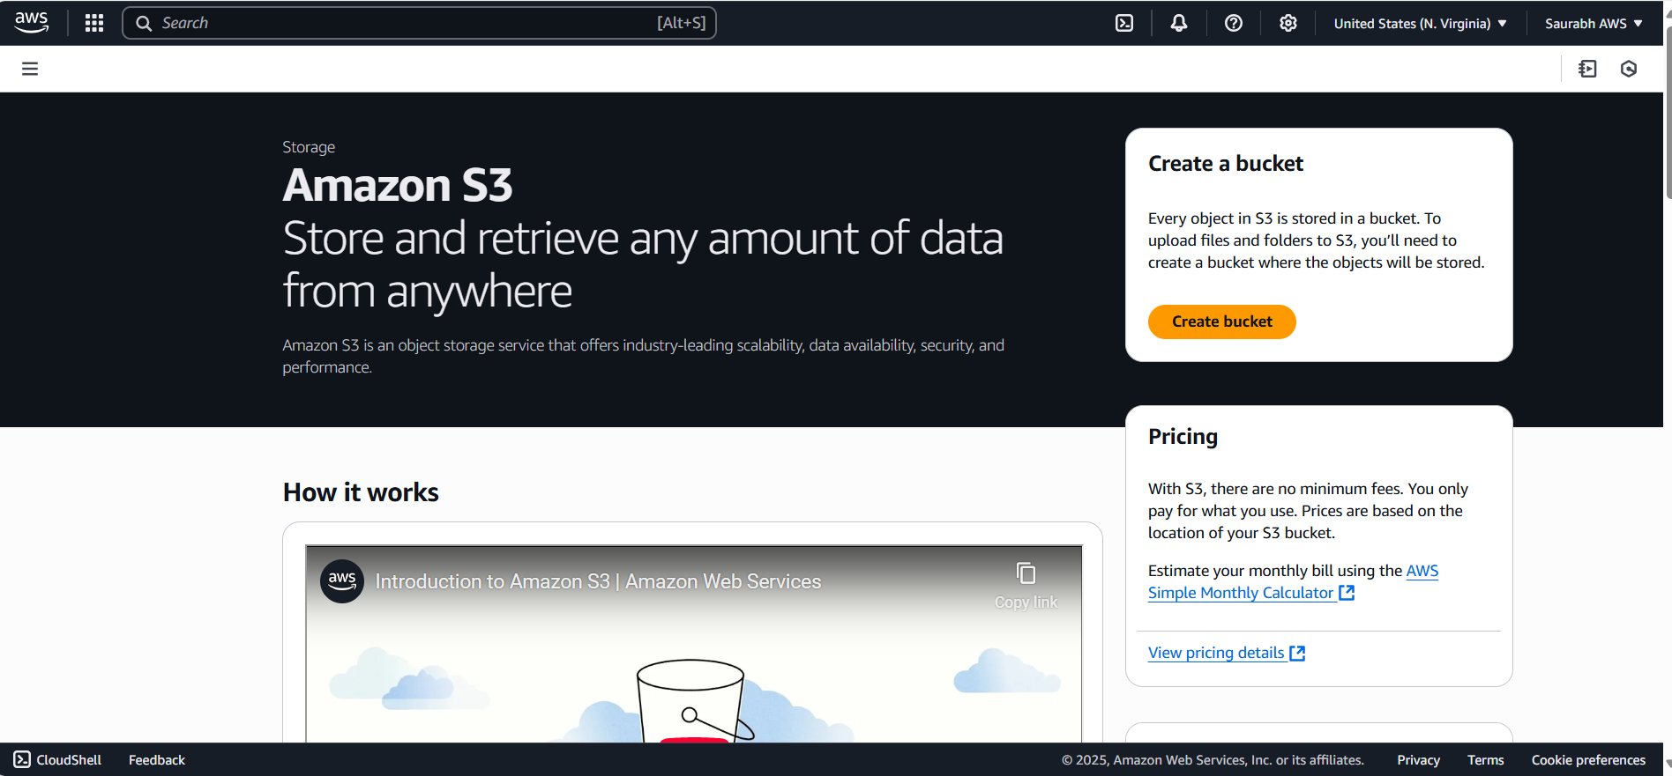

1. It will by default take the AWS region already selected. Select the bucket type as General purpose. Provide unique bucket name as S3 is a **global service**.

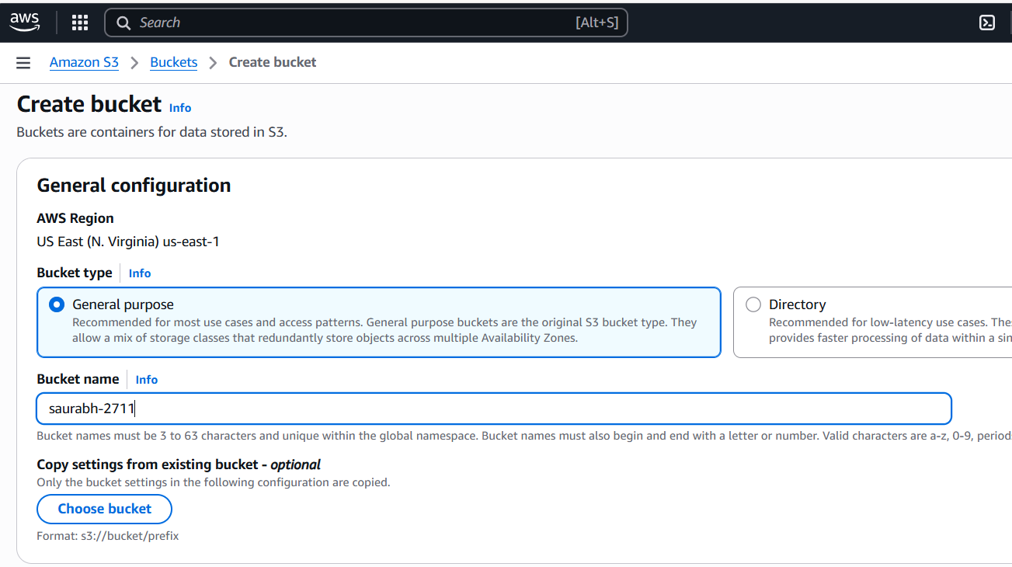

1. Enable the ACL

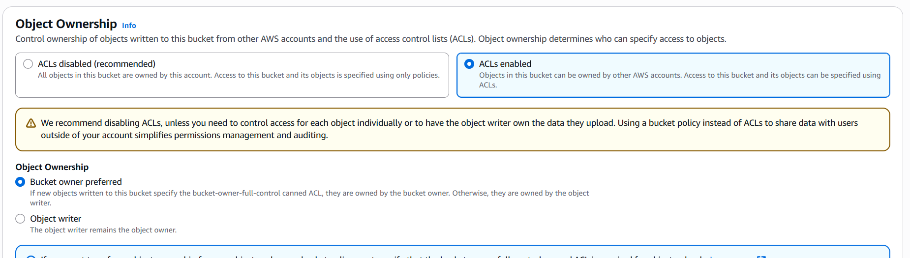

1. Unblock the public access.

1. Keep other options as default and click on create bucket.

1. Navigate to the bucket. There we can upload the files.

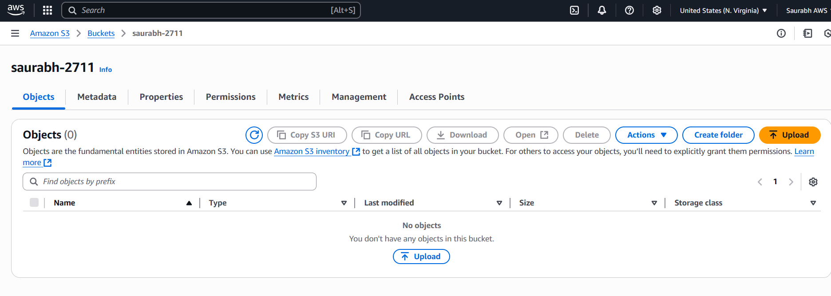

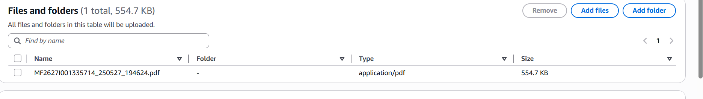

1. Provide ACL permission as public.

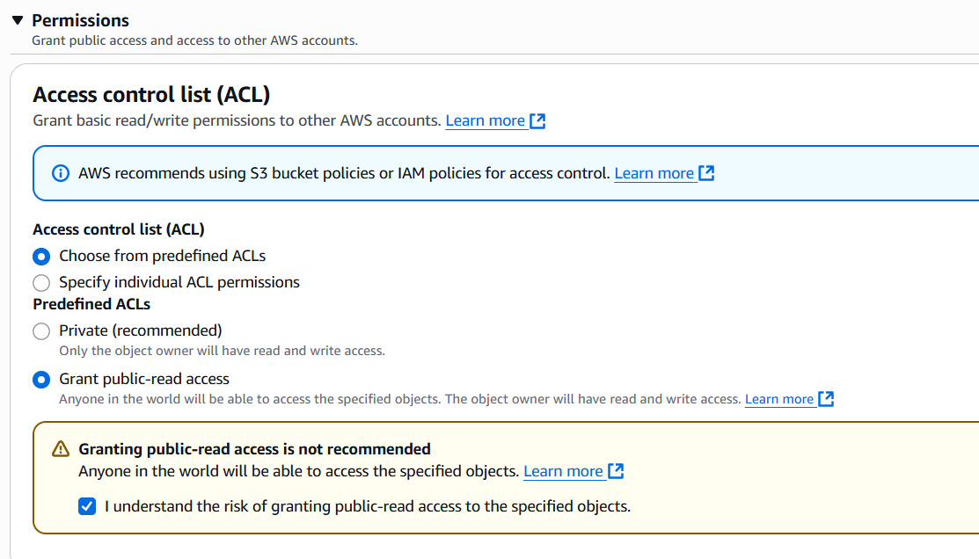

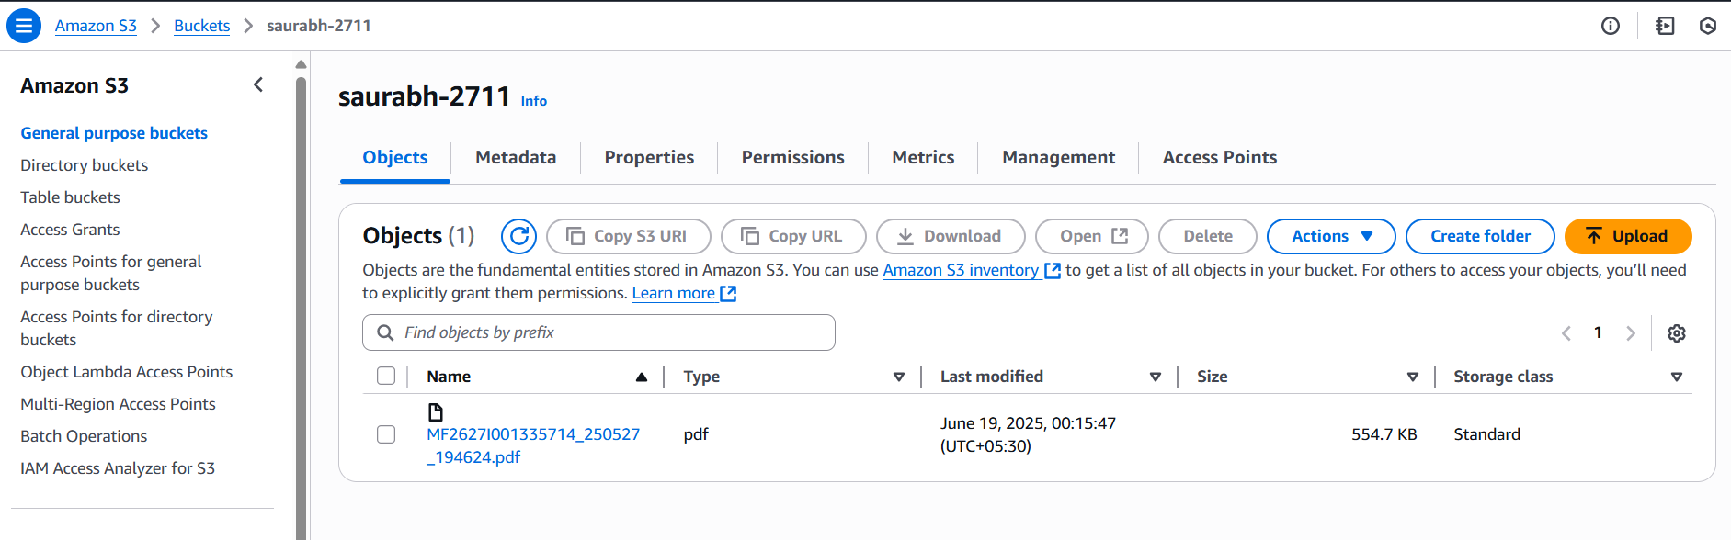

We can access the file using Object url.

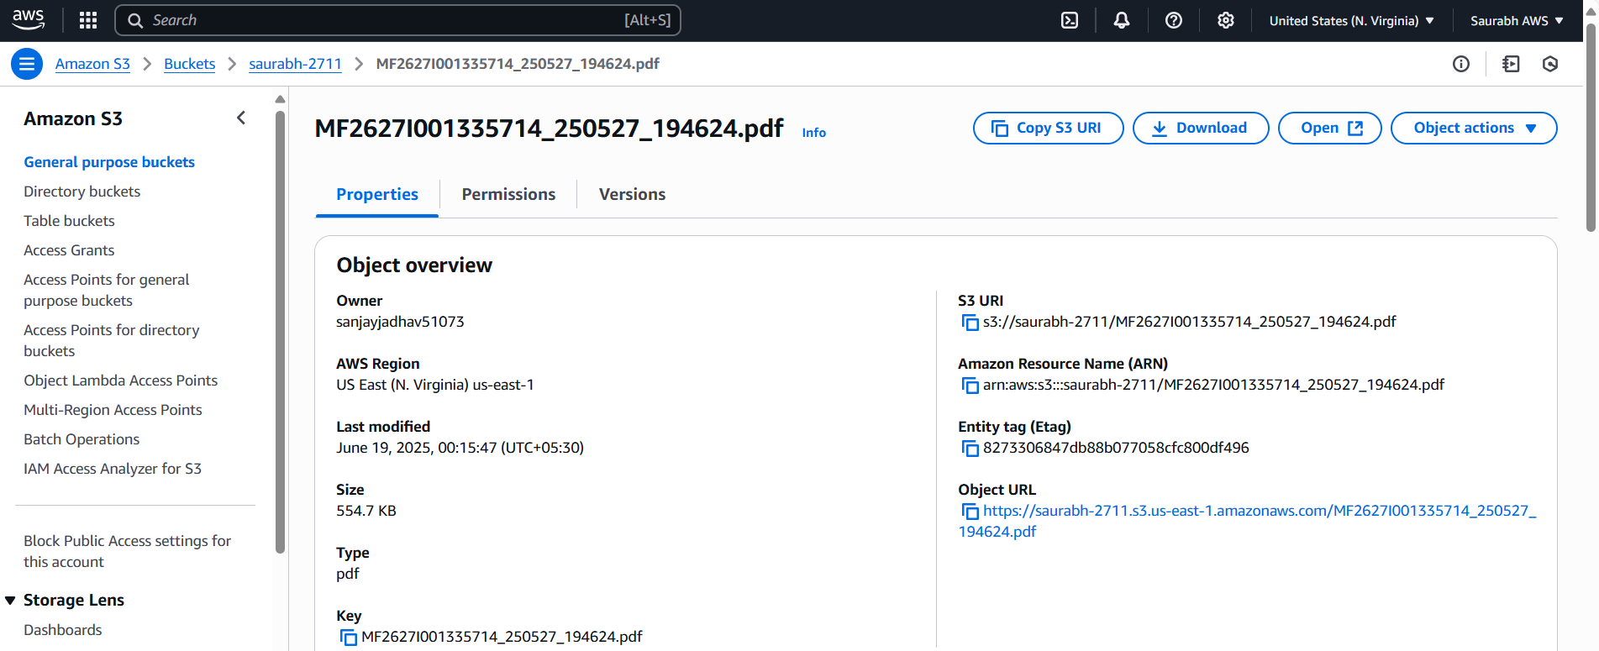

File is accessed using the url.

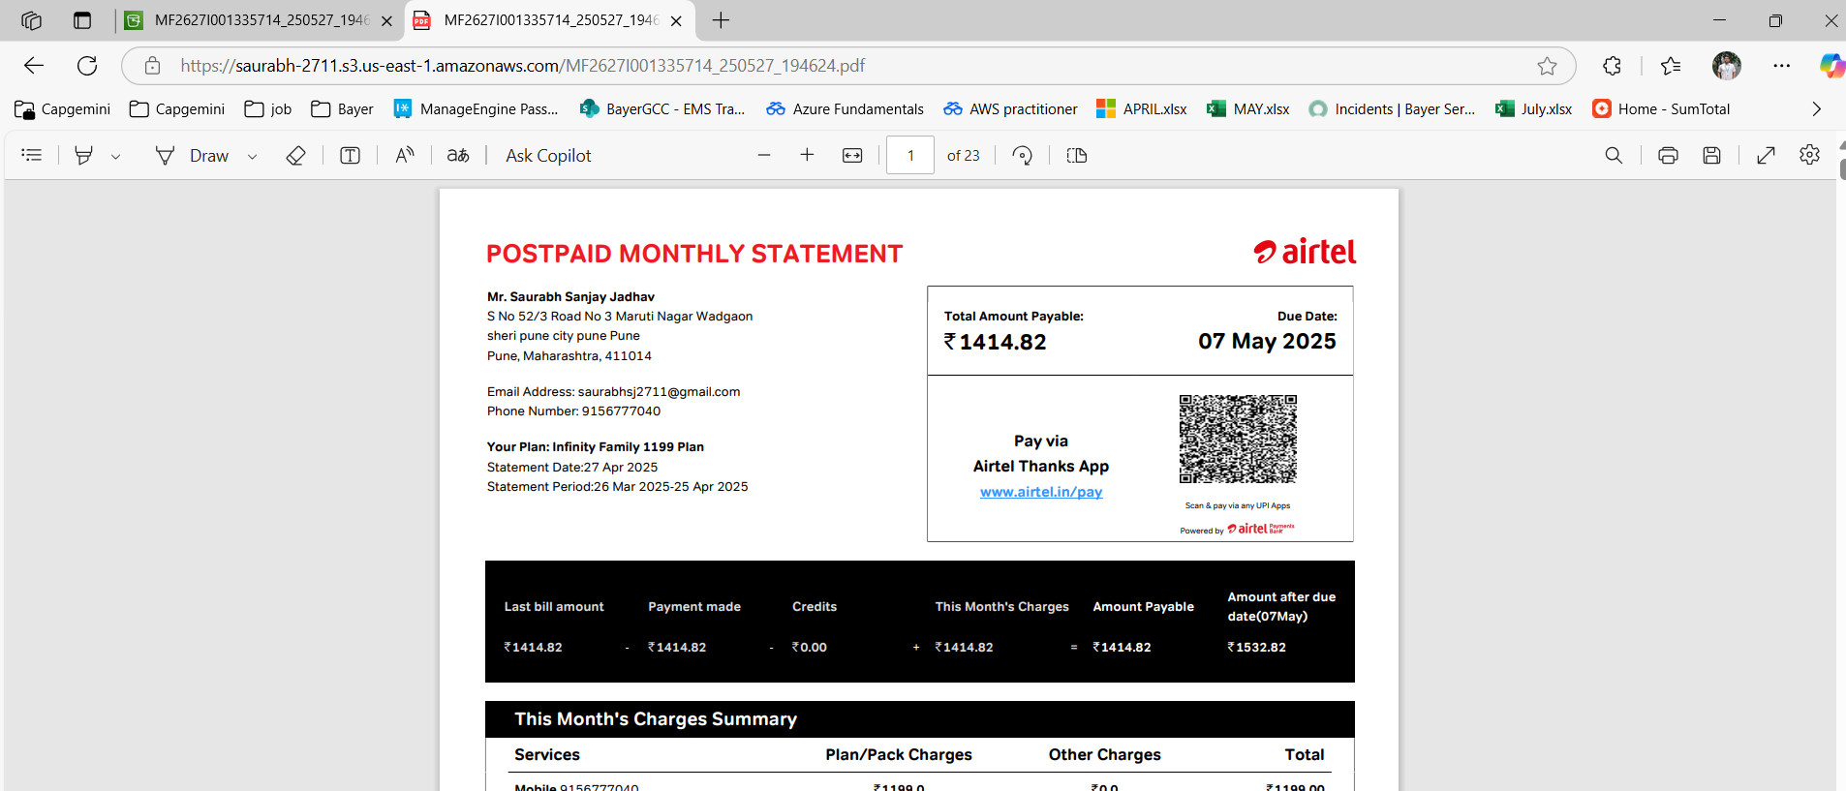

1. Provide private access to ACL permissions.

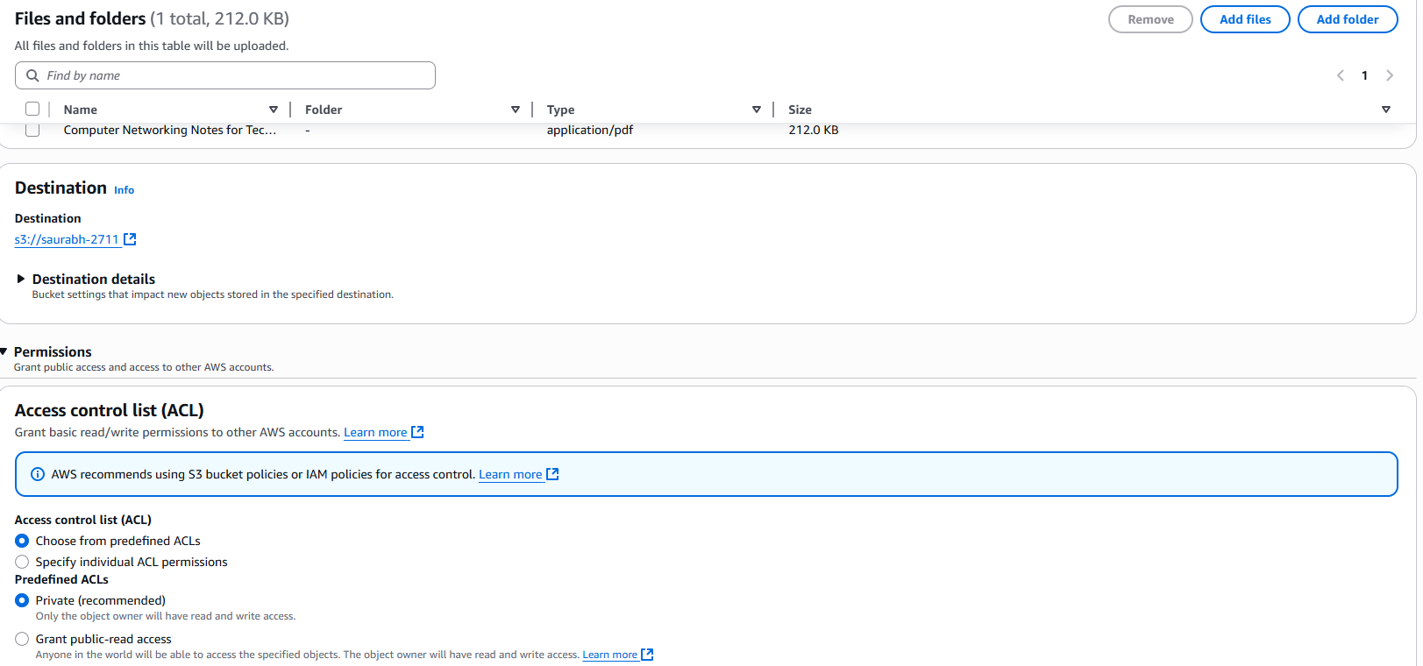

Copy the object url.

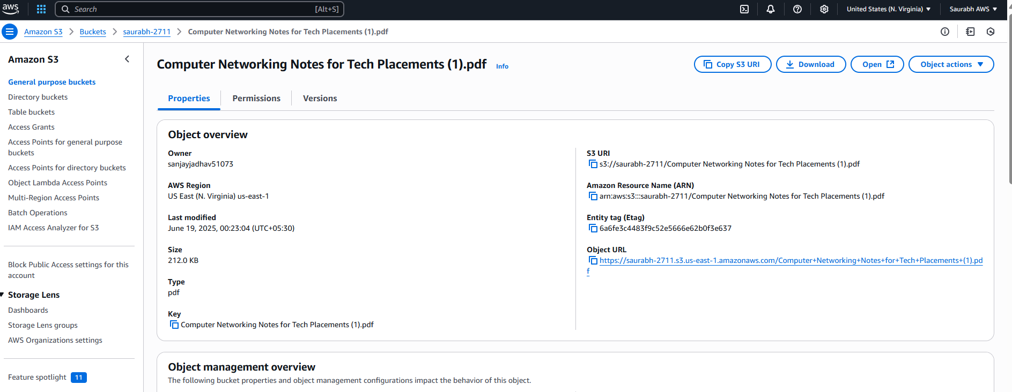

But access is denied to the file.

We can access the file as a owner only.

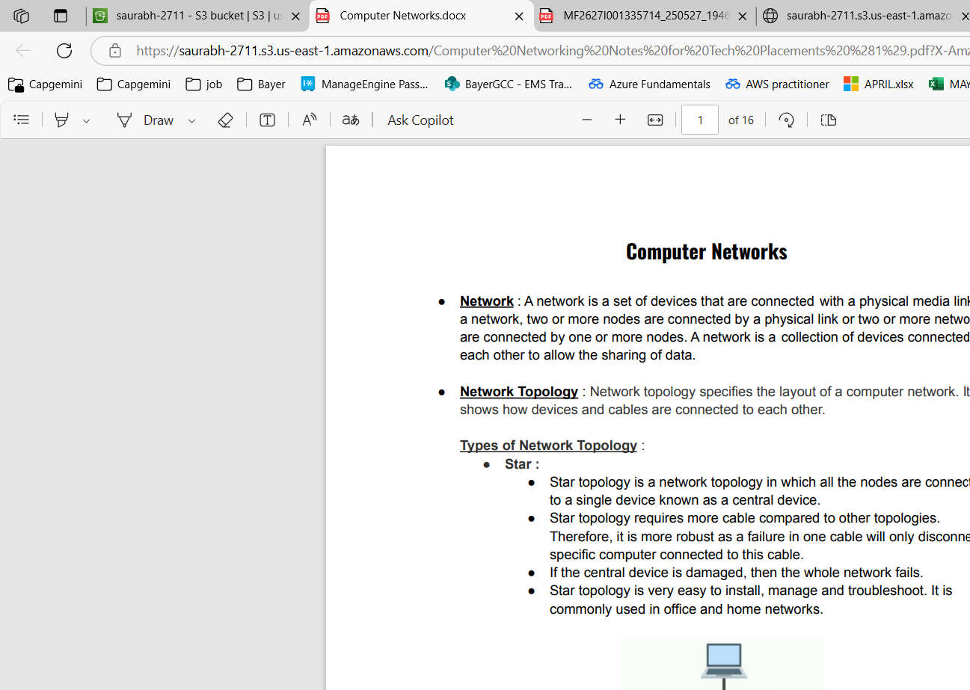

1. For deleting the files select the files and click on delete.

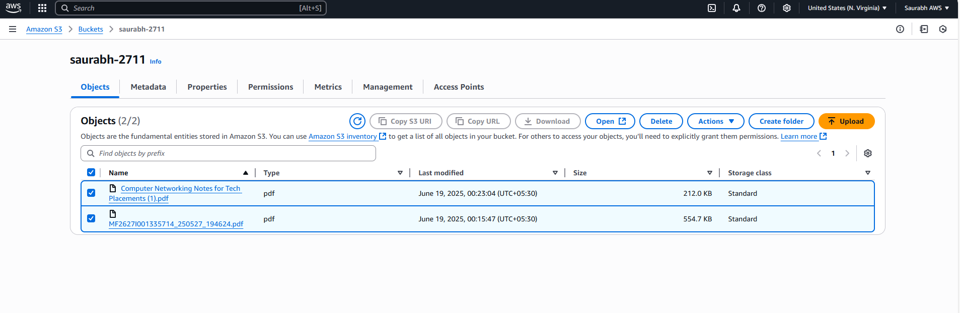

1. Finally delete the bucket.

